Ideation Phase
Brainstorm & Idea Prioritization Template

Date | 25 June 2026
Team ID
Project Name | An employee requests installation of licensed software through the Service Catalog
Maximum Marks | 4 Marks

Brainstorm & Idea Prioritization Template:
Brainstorming was conducted to identify an efficient solution for managing software installation requests. The team discussed issues in the manual request process, such as approval delays, poor tracking, and communication gaps. Various ServiceNow features, including the Service Catalog, Workflow, Business Rules, and Catalog Tasks, were considered.
After evaluating different ideas based on feasibility and business value, the team selected a Software Installation Request Automation System. The solution enables employees to submit software requests through the Service Catalog, automates approvals and task creation, and improves request tracking, efficiency, and user experience.

Reference: https://www.mural.co/templates/brainstorm-and-idea-prioritization
Step-1: Team Gathering, Collaboration and Select the Problem Statement
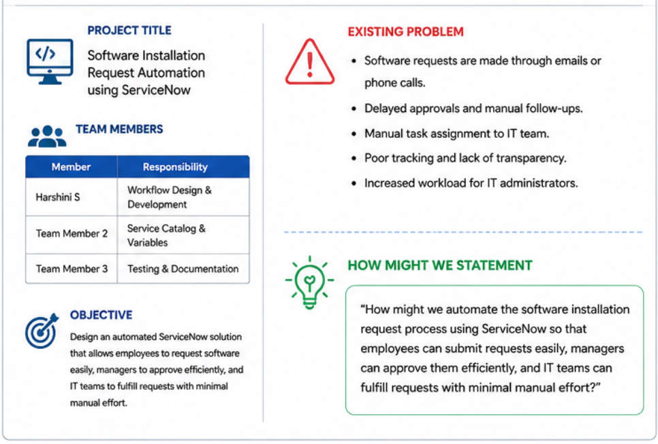

Step-2: Brainstorm, Idea Listing and Grouping
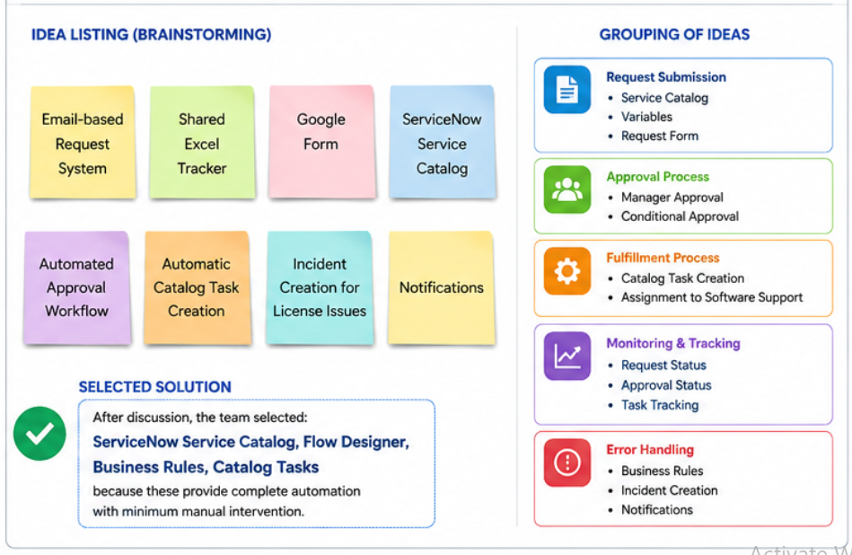

Step-3: Idea Prioritization
